**HIVE**

**Class: 14 DATE: 07-07-2024**

2006 🡺 Hadoop launched (HDFS, MapReduce)

2008 🡺 Big Challenge: MapReduce is extremely tough and complex to understand.

In real time, Hadoop is majorly used by Data Engineer and their strength is SQL. But in 2008 we have only processing engine available was MapReduce. To understand MapReduce (MR), to use MR, to develop MR code, Deploy MR code, to Run MR code one needs to be well versed in JAVA.

* MapReduce is Very Complex.
* MR does not have SQL support.
* Even for small filter you have to deploy the code
* Never easy to understand the code and to code
* Never a user friendly

2008 🡺 **Joydeep Sen Serma** found a tool that eliminate complete using of MapReduce but can use Hadoop. Also **enabled SQL alike on Hadoop.** Its look like SQL but not SQL. At front we can shoot SQL queries but at backend, MapReduce works.

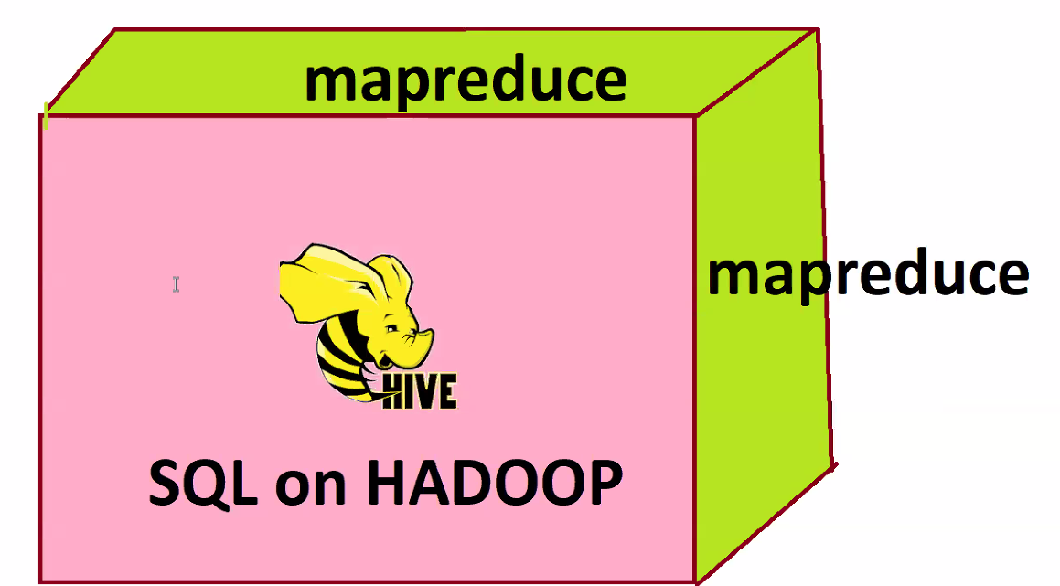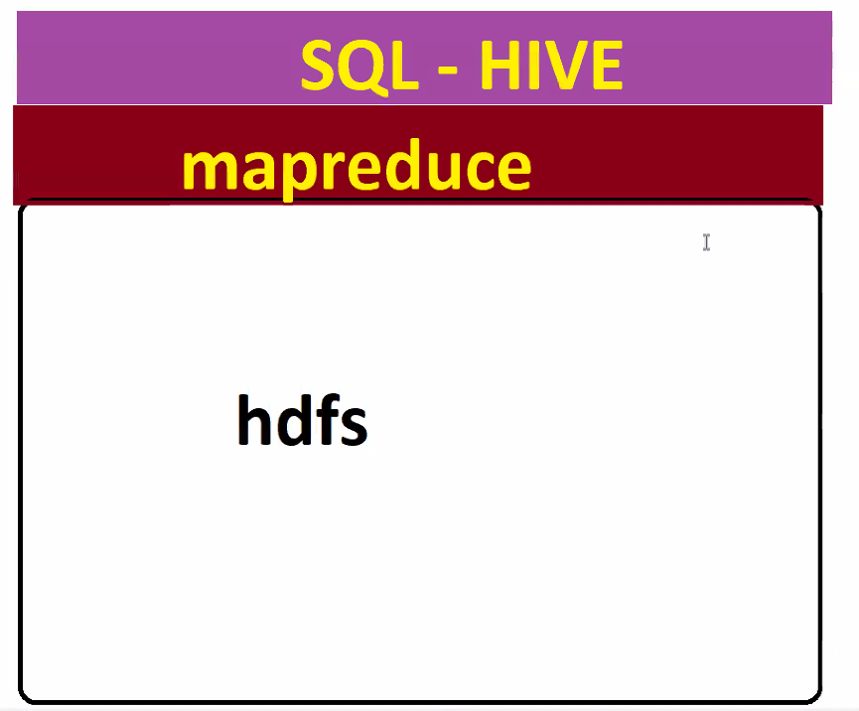

**Class: 15 DATE: 13-07-2024**

**Agenda**

* **Recap on HIVE**
* **Hive vs SQL deep – VV imp for interviews**
* **Hive warehouse execution with HDFS -- handson**
* **Hive DB creation with table -- handson**
* **Hive Data loads -- handson**

Hive is SQL layer on Hadoop. The Ideology of HIVE changed entire World. HIVE is mother of Snowflake, BigQuery, Athena, RedShift etc.

SQL and HIVE are both are exactly opposite to each other. SQL runs on database; HIVE runs on FILESYSTEM(HADOOP).

**SQL VS HIVE**

1**. SQL deal with Database**, that’s why when queried in SQL it returns data in table structure.

**Hive is kind of Data warehouse** on HDFS File system, when we shoot hive queries, data comes from FILE at backend.

2. **SQL is ETL in Nature**. Say we have serialized parquet file called data.parquet, we have **ptab** sql table. Now we have to load this parquet data to SQL table. When we load parquet data to sql, sql cannot accept whatever data format you load. Before loading, we have to transform from parquet to structured format(CSV FORMAT) then load.

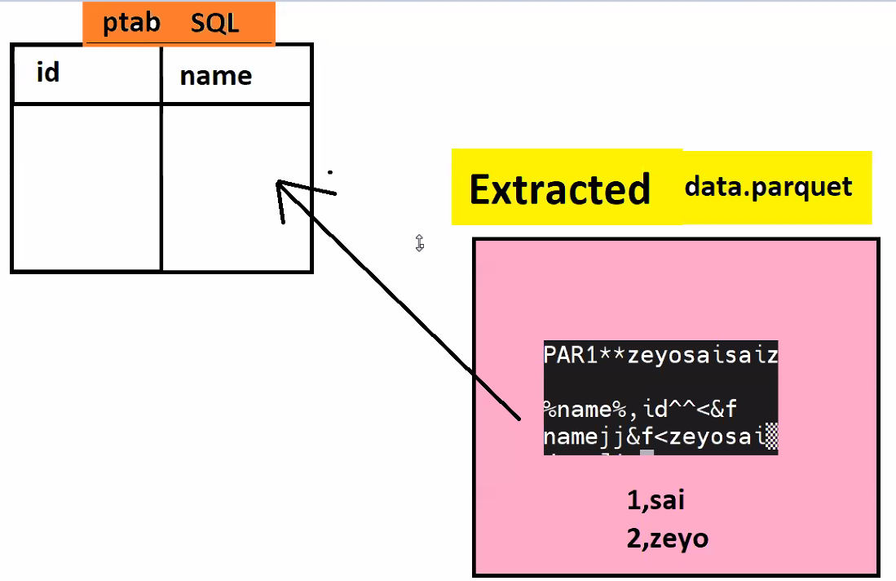

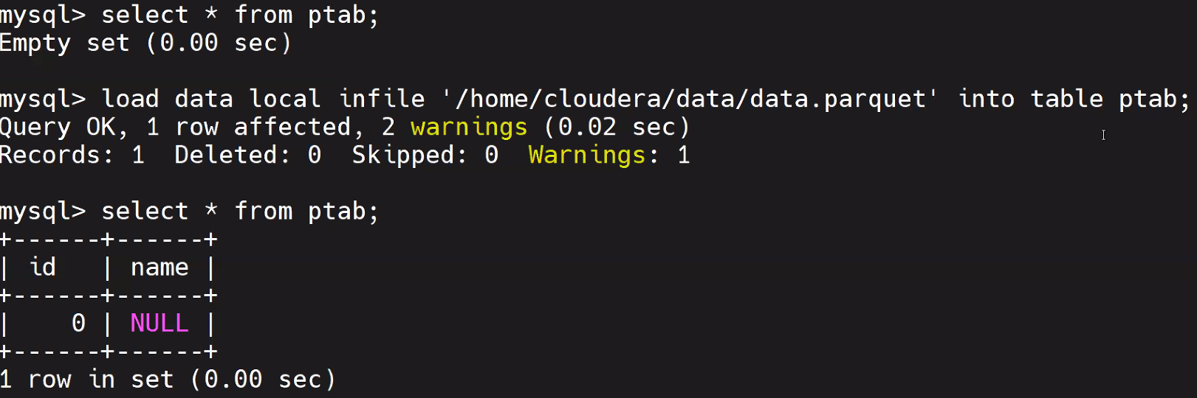

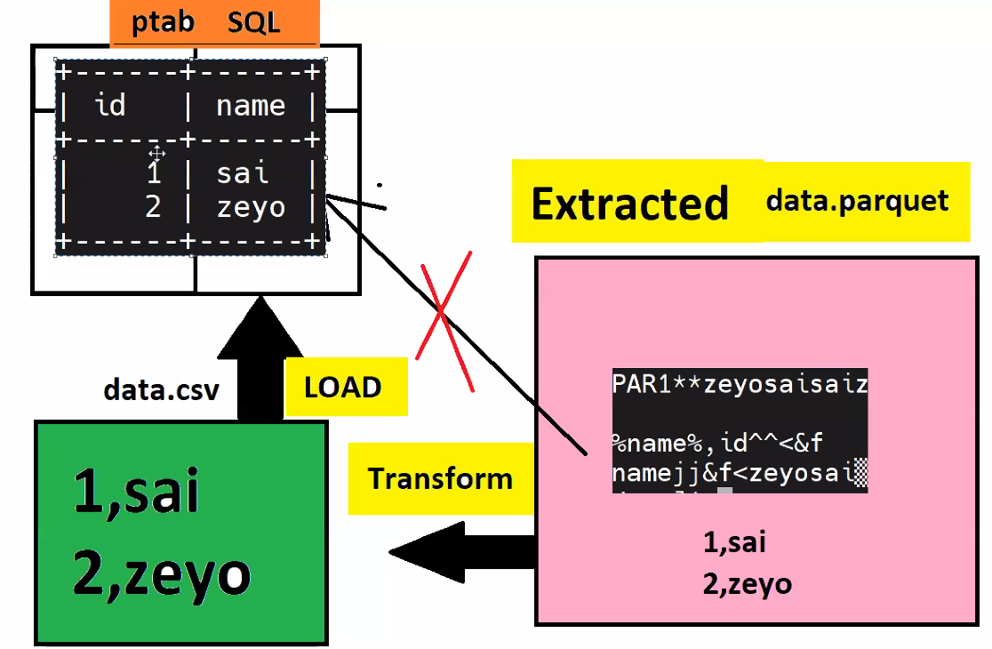

In the above example in order to load data from parquet to sql, first we have to **extract the data** then **transform the data** from parquet to csv file format then **load the data**. This Process is ETL process.

**Hive is ELT** in Nature. Say we have **ptab** table in **hive**. When we **extract** the raw parquet data, firstly we **load** the data. Later on do whatever we want to do **transformations**. This process is ELT Process.

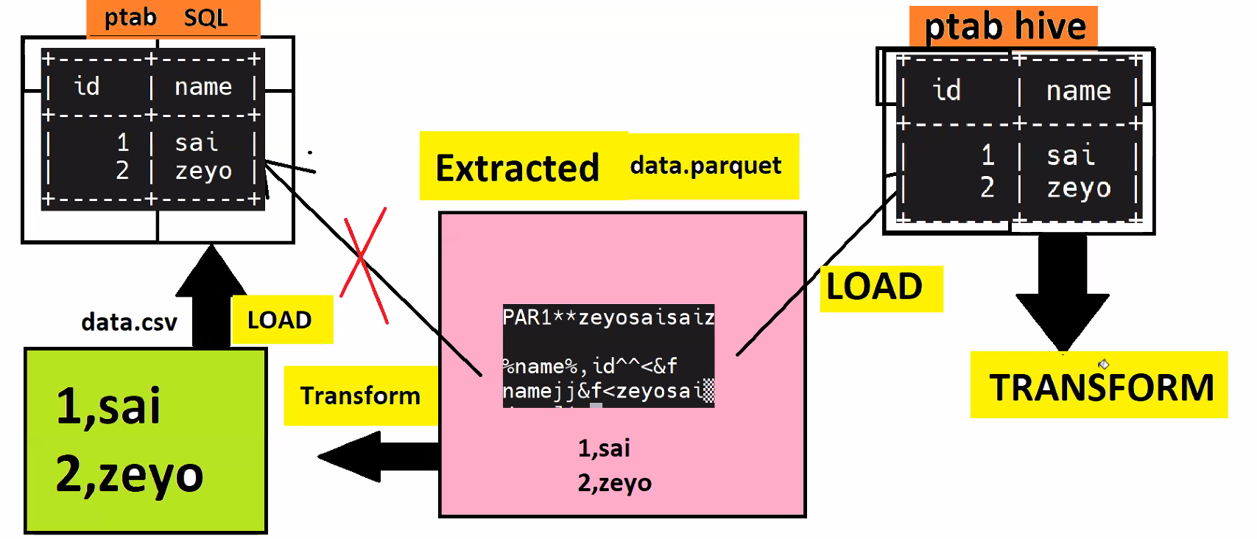

3. SQL is **Load time parsing**. Imagine we have **ntab (id int, name varchar)** SQL table and sdata.csv, if try to load, it fails because ntab table will accept only int data in ID column. As csv data has some string data in id column, SQL does some validation before loading. It reset the data where there is datatype mismatch happens. During load itself it is validating the data for datatype match, so we call it as **load time parsing.**

Hive is **Query Time Parsing**. SQL resets/changes the data while data load, when it Faces datatype mismatch. But hive will not do any reset, even though there is column datatype mismatch it directly loads the data into table. But schema validation happens not during the load, validation happens when we query the data. When there is datatype mismatch of data in any column in table, it sends that cell value as **NULL.** Data wont be changed at backend. Here table creation with int column in biggest mistake.

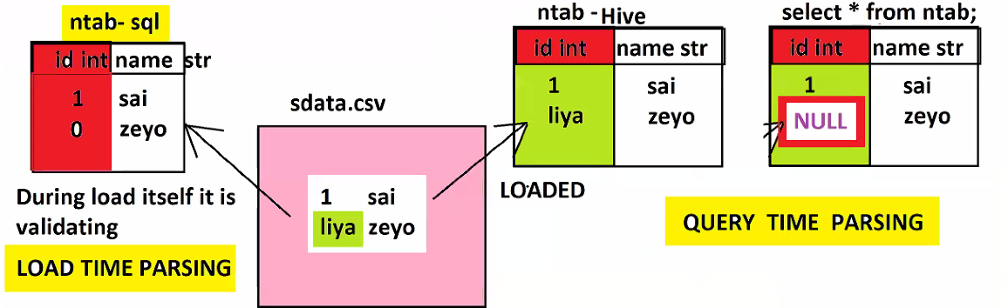

Load time Parsing is also called as Schema on Write. Query time parsing is also called as Schema on Read.

4. SQL is majorly used for **structured data(CSV).** Hive supports **Structured(csv) and Semi-Structured(json,xml,serialized) Data**. Unstructured data required lots of customizations. It’s bit hard to handle them via SQL or HIVE.

5. **SQL is not meant for Big Data**, large Data, Bulk data, query takes time. **Hive is not good for Small data**.

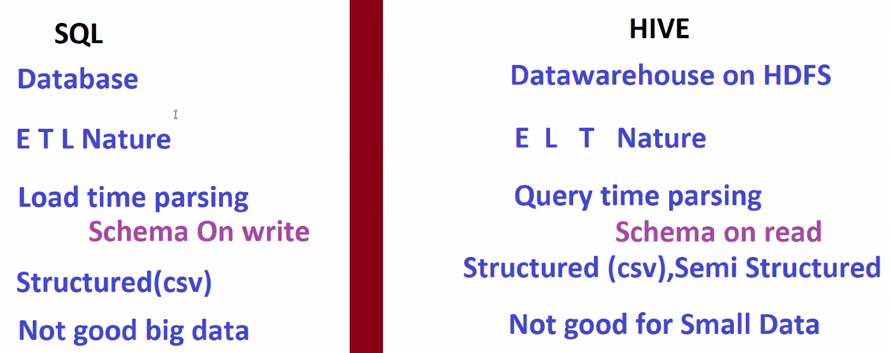

====================================================================================================

AS Hive is working on top of HDFS, Whatever we do in HIVE it reflect in HDFS at Backend.

How to go inside HIVE SHELL? Just type hive in shell.

This is the path where hive points to **hadoop fs -ls /user/hive/warehouse**

**once we create database in HIVE CLI, it creates directory/folder on database name in above mentioned warehouse path at backend. Also similarly when we create a table inside that database, it create another directory on table name. When we insert data into table, it again creates file 000000_0 and puts data inside that file.**

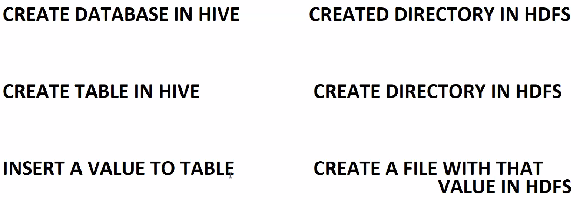

**Every HDFS has directory specific to Hive 🡺 /user/hive/warehouse**

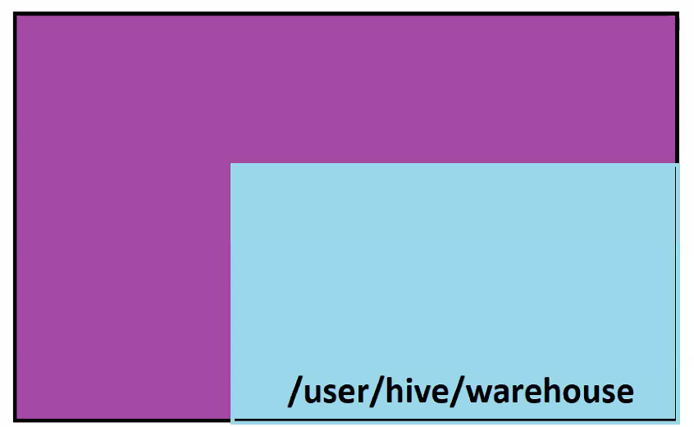**Even though hive has its own dedicated directory, does not meant that hive is restricted to that path only. It also has access to other directories in HDFS.**

**Task 1 ---**

**🔴 Cloudera Folks**

**hadoop dfsadmin -safemode leave**

**hive ---> type and enter**

**create database mdb;**

**use mdb;**

**create table mtab(id int);**

**insert into mtab values(1);**

**select * from mtab;**

**quit;**

**hadoop fs -ls /user/hive/warehouse/**

**hadoop fs -ls /user/hive/warehouse/mdb.db**

**hadoop fs -ls /user/hive/warehouse/mdb.db/mtab**

**hadoop fs -cat /user/hive/warehouse/mdb.db/mtab/000000_0**

**Task 2 -----**

**hive ---> type and enter**

**drop database mdb cascade;**

**quit;**

**hadoop fs -ls /user/hive/warehouse/**

**Task 3: Difference between OLTP vs OLAP.:**

**ICICI Bank saying**, hey today so many people has done many transactions, bring that data so that we will analyse which state has done so many transactions – so that we can release some offers to them.

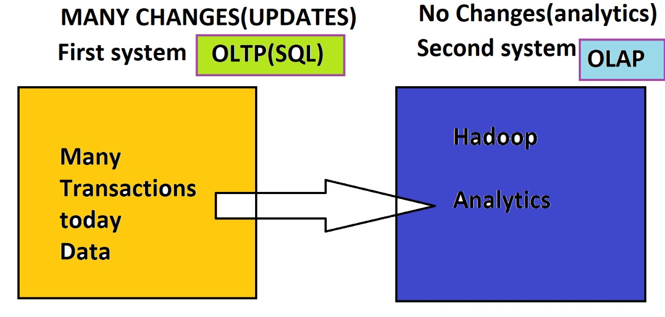For Transactions and analytics, ICICI is maintaining 2 different servers. If there are many changes or updates are on transactions server that is called OLTP. No changes or updates will be done that is called OLAP.  
if the data keep changes there we keep OLTP system there , where data doesn’t change there we keep OLAP system.

**Class: 16 DATE: 14-07-2024**

**Agenda:**

* **Recap on Hive**
* **Table creation Deep**
* **Edge node loads**
* **Location table creation**
* **Types of tables – Buffer**

**Table creation Deep:**

Create a database called **zdb in Hive,** table with below details –

* Table name 🡺 zeyotab
* Columns 🡺 id int, name string, amount int
* Delimited 🡺 ‘,’ (comma)
* Location 🡺 NA

**Table creation syntax:**

**create table zeyotab(id int, name string, amount int) row format delimited fields terminated by “,” ;**

**Every table in hive need a directory. So while creating a table we have to give directory location of table to hive to get pointed. If we didn’t give a directory, hive itself creates a directory on table name in warehouse and gets pointed.**

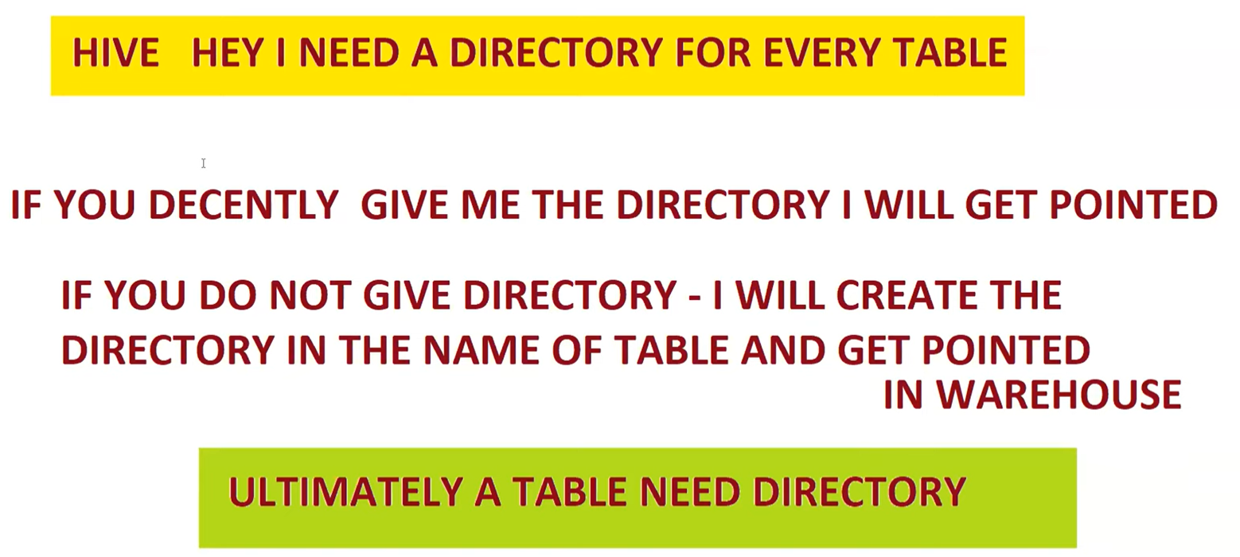

**describe formatted <table names> 🡺 give information about table, like where that table location is pointed to.**

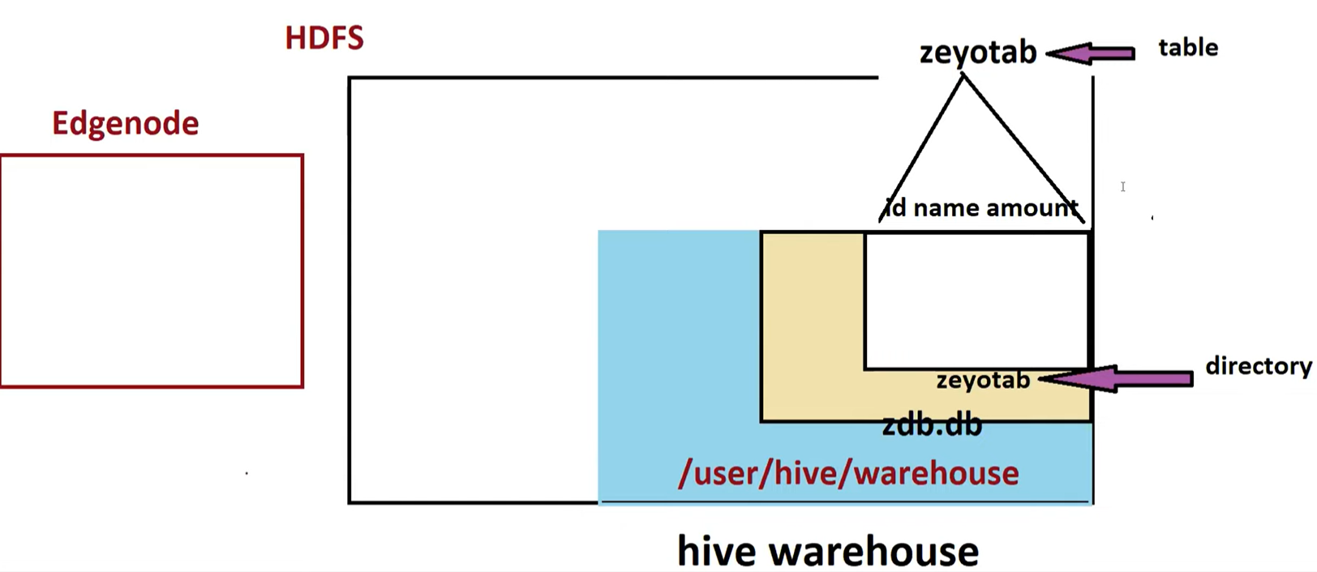

**Table drop:**

**drop table zeyotab;**

once we execute above statement all the table directories at backend get deleted.

Lets create a new table in zdb database with below details –

* Table name 🡺 ztab
* Columns 🡺 id int, name string, amount int
* Delimiter 🡺 ‘,’
* Location 🡺 NA

**create table ztab(id int, name string, amount int) row format delimited fields terminated by ‘,’;**

**Loading data from Edge node into Table ztab without LOCATION:**

**load data local inpath ‘/home/cloudera/zfile’ into table ztab;**

once we execute above statement, the zfile gets copied to table directory.

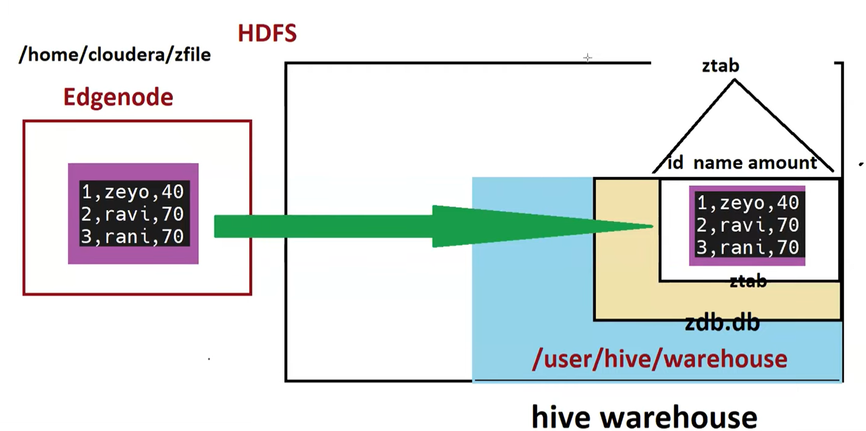

**WITHOUT LOCATION in LOAD COMMAND:**

hadoop dfsadmin -safemode leave

cd

echo 1,zeyo,40 > zfile

echo 2,ravi,70 >> zfile

echo 3,rani,70 >> zfile

hive -- type and enter

drop database if exists zdb cascade;

create database if not exists zdb;

use zdb;

create table ztab(id int,name string,amt int) row format delimited fields terminated by ',';

load data local inpath '/home/cloudera/zfile' into table ztab;

select * from ztab;

select * from ztab where id>1;

quit;

hadoop fs -ls /user/hive/warehouse/zdb.db/ztab

**Table Creation with LOCATION**

Create a new database **ldb,** create table with below details –

* Table name 🡺 ltab
* Columns 🡺 id int, name string, amount int
* Delimiter 🡺 ‘,’
* Location 🡺 /user/cloudera/

**load data local inpath ‘/home/cloudera/zfile’ into table ztab location <filepath>;**

**table directly gets pointed to mentioned location**

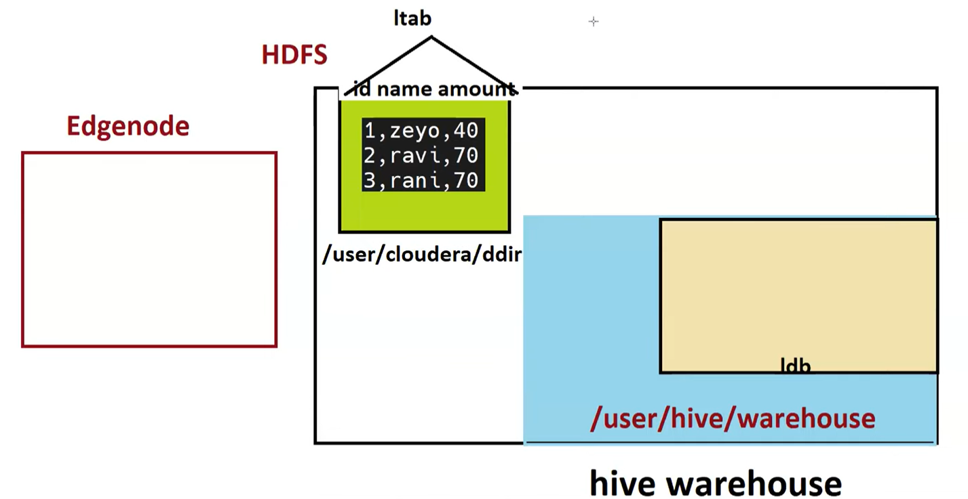

**WITH LOCATION in LOAD COMMAND:**

hadoop dfsadmin -safemode leave

cd

echo 1,zeyo,40 > zfile

echo 2,ravi,70 >> zfile

echo 3,rani,70 >> zfile

hadoop fs -mkdir /user/cloudera/datadir

hadoop fs -put /home/cloudera/zfile /user/cloudera/datadir/

hive -- type and enter

drop database if exists zdb cascade;

create database if not exists zdb;

use zdb;

create table ltab(id int,name string,amt int) row format delimited fields terminated by ',' location '/user/cloudera/datadir';

select * from ltab;

select * from ltab where id>1;

quit;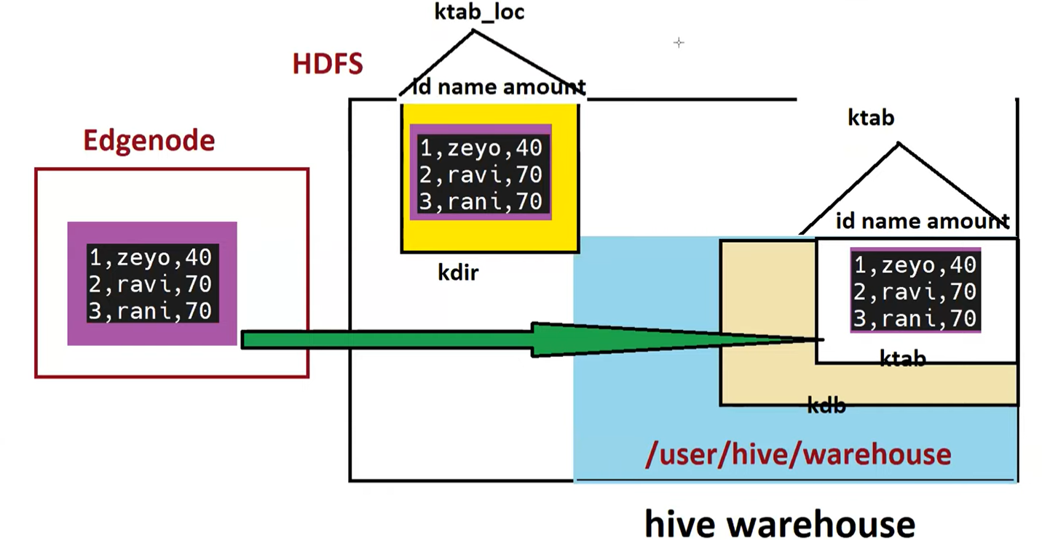

**PRACTISE SCENARIO:** Say we have 3 directories, dir1, dir2, dir3, have file1,file2,file3 in respective dirs.. as shown below

Create tables on each of above dir -- tab1, tab2,tab3

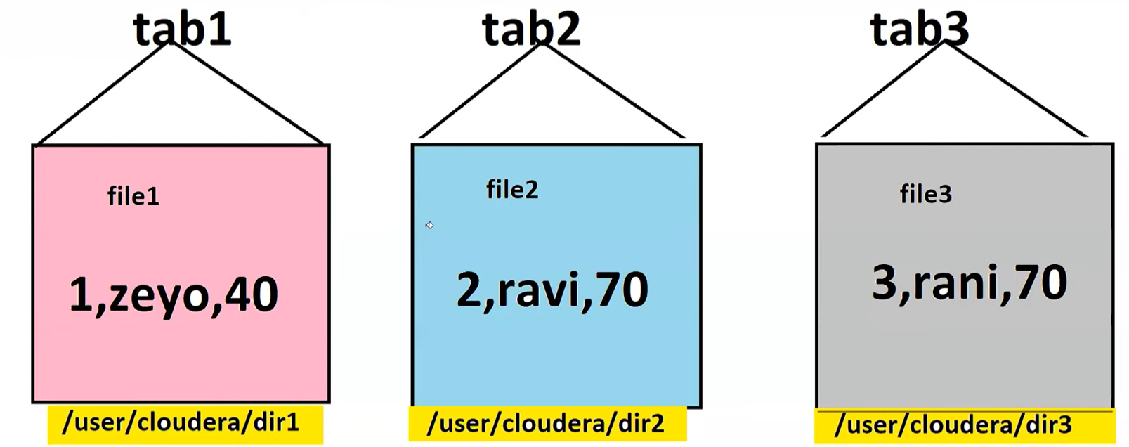

We have 2 directories in HDFS named, **mdir,edir.**

Create mtab table on mdir ---

Create table mtab(id int, name string, amount int) row format delimited fields terminated by ‘,’ location ‘/user/cloudera/mdir’ ;

Select * from mdir;

describe formatted mtab; 🡺 gives table types.

if we drop the table, the table directory gets deleted from HDFS (‘/user/hive/warehouse/’) because the table which we created is **Managed_Table.**

The functionality of **Managed Table** is if we drop the table it would delete the backend directory.

If the table is dropped and if we don’t want to backed directory impacted or deleted, we have to create another type of table called **External_Table.**

**Types of tables in HIVE:**

We have two types of tables in hive:

* **MANAGED_TABLE**
* **EXTERNAL_TABLE**

**The major difference between Managed_Table and External_Table is – if we drop Managed_Table, backend directory gets deleted along with table. If we drop External_Table, backend directory stays back and drops only table.**

Whatever the tables created till was Managed_Tables.

**EXTERNAL_TABLE CREATION:**

**Create external table etab(id int, name string, amount int) row format delimited fields terminated by ‘,’ location ‘/user/cloudera/edir/’**

**Commands:**

hadoop dfsadmin -safemode leave

cd

echo 1,zeyo,40 > zfile

echo 2,ravi,70 >> zfile

echo 3,rani,70 >> zfile

hadoop fs -mkdir /user/cloudera/mdir

hadoop fs -mkdir /user/cloudera/edir

hadoop fs -put zfile /user/cloudera/mdir

hadoop fs -put zfile /user/cloudera/edir

🔴 hive --- Go Inside Hive

create database if not exists zdb;

use zdb;

create table mtab(id int,name string,chk string,country string) row format delimited fields terminated by ',' location '/user/cloudera/mdir/';

select * from mtab;

describe formatted mtab;

create external table etab(id int,name string,chk string,country string) row format delimited fields terminated by ',' location '/user/cloudera/edir/';

select * from etab;

describe formatted etab;

drop table mtab;

drop table etab;

show tables; ==== mtab,etab tables do not exists

quit;

hadoop fs -ls /user/cloudera/; ===> U will see edir not mdir

**Class: 17 DATE: 20-07-2024**

**PREDICATE PUSHDOWN:** Supports only for Parquet

As parquet supports pure columnar data format, predicate pushdown is nothing but it takes all the required columns to RAM for processing and it pushes down all the unnecessary columns to HDD.

Predicate Pushdown is a feature of Columnar file and databases, for which it would bring only the required columns to the RAM to process and push down unnecessary columns to HDD.

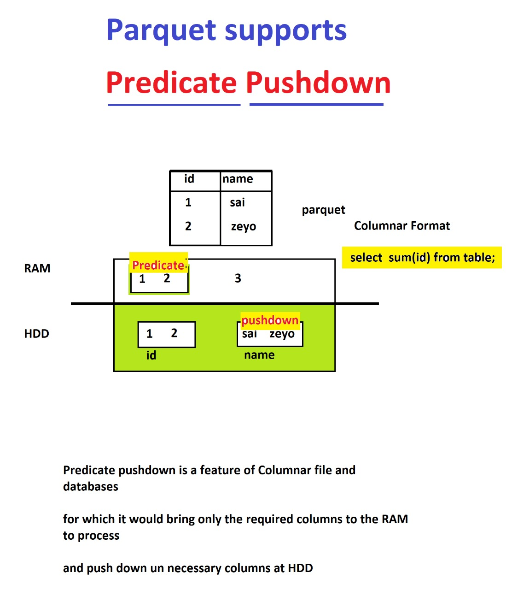

**Agenda:**

* **Recap on Hive**
* **Recap on Types of Tables**
* **Partitions**
* **Static Load Partitions**
* **Static Insert Partitions**
* **Dynamic Partitions – Buffer**

Managed tables and External tables are same in everything like performance, functionality etc, the only difference between them is drop functionality.

When to use what table:

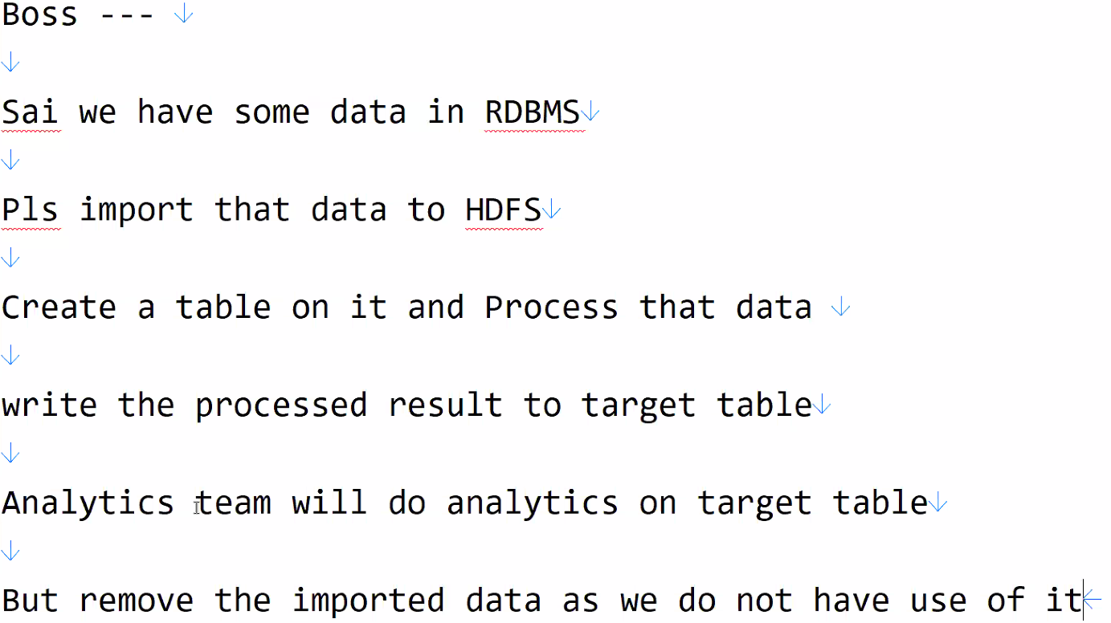

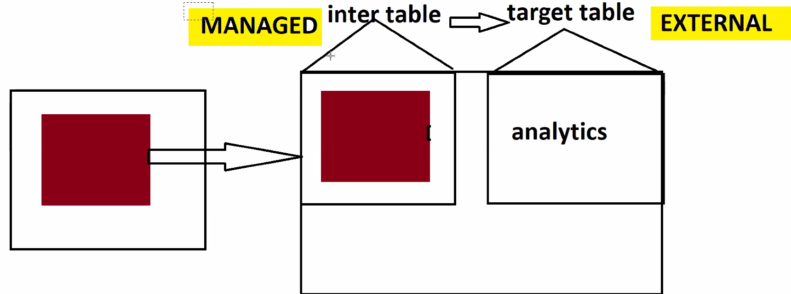

Inter Table 🡺 Must be Managed Table, should not be External

Target Table 🡺 must be External table, should not be Managed

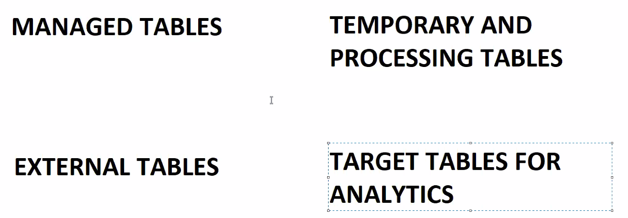

**HIVE PARTITIONS (vv imp for interviews): Partitions is not only a Hive topic, it’s a Big-data topic.**

Partition is an OPTIMIZATION TECHNIQUE, which increases performance, saves time and cost.

CASE 1: Imagine we have two tables, one table has 10M IND records, 10M US records, 10M UK records. When we query for count IND records, then it will be scanning entire database that is 30M rows will be scanned. But result is only 10M. Here my required data is only 10M but unnecessarily we are scanning entire 30M data.

CASE 2: Now, data is partitioned with every column, means 10M IND records are partitioned, 10M US records are partitioned, 10M UK records are partitioned. Now when we query for count IND records, then it will scan only IND partition data that is 10M rows will be scanned not entire database.

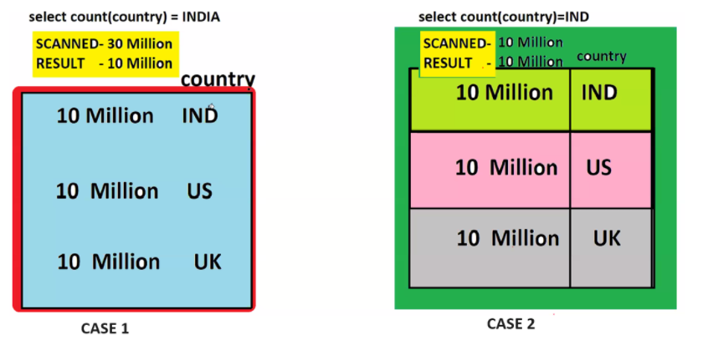

Say we have 2 tables ntab, ptab where ntab is normal table, ptab is partition table as show below –

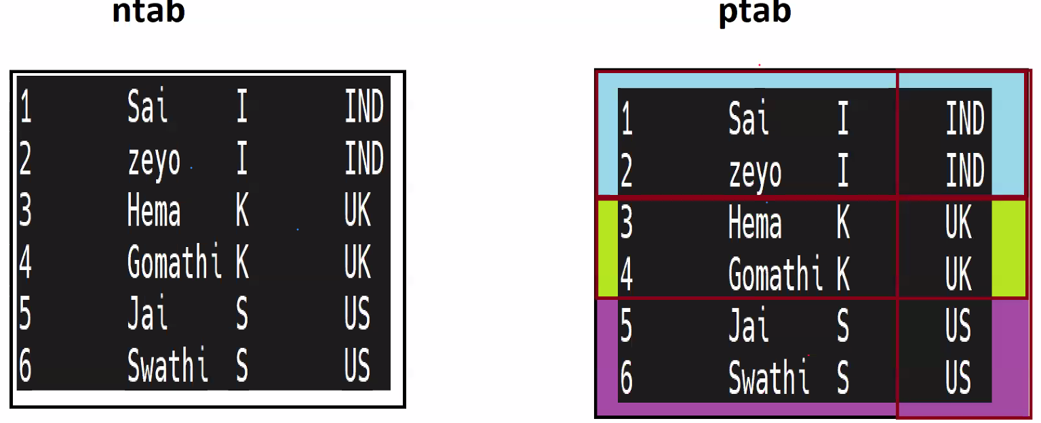

How do u recognize between these Partitions tables: go check directories of these tables in HDFS.

Inside ndir directory, we will have one file which has all records.

Inside pdir directory, there will be 3 folders, one for each country, each country has one file in it with related country data in it.

**PARTITIONS ARE JUST SUB FOLDERS.**

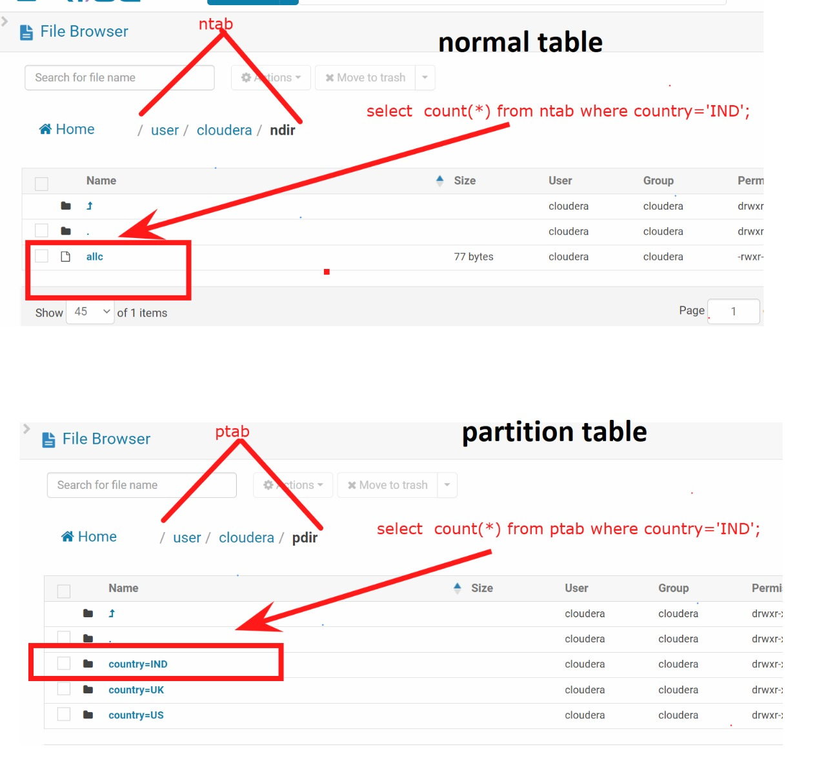

* Partitions used for Optimization.
* Partitions are used for performance tuning.
* Partitions scans only required data
* Partitions are just sub folders.

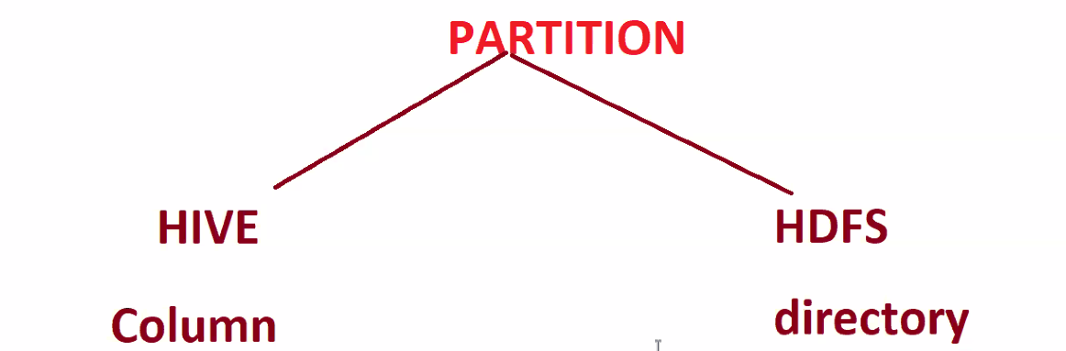

* Hive understanding a partition is **Column.**
* HDFS understanding a partition is **directory.**

**HIVE STATIC LOAD PARTITIONS CREATION COMMAND**

Create a partdir in HDFS.

Using below tables create table:

* Tablename 🡺 parttab
* Columns 🡺 id int, name string, chk string
* Delimiter 🡺 ‘,’
* Location 🡺 /user/cloudera/partdir
* Partition column 🡺 country string

**create table parttab (id int, name string, chk string) partitioned by (country string) row format delimited fields terminated by ‘,’**

Load these three files from edge node to partitioned table

* /home/cloudera/INDTxns
* /home/cloudera/UKTxns
* /home/cloudera/USTxns

Load INDTxns to the partitioned table with partition name as **INDIA**

* **load data local inpath ‘/home/cloudera/INDTxns’ into table parttab partition (country=’INDIA’)**

Load UKTxns to the partitioned table with partition name as **UK**

* **load data local inpath ‘/home/cloudera/UKTxns’ into table parttab partition (country=’UK’)**

Load USTxns to the partitioned table with partition name as **USA**

* **load data local inpath ‘/home/cloudera/USATxns’ into table parttab partition (country=USA’’)**

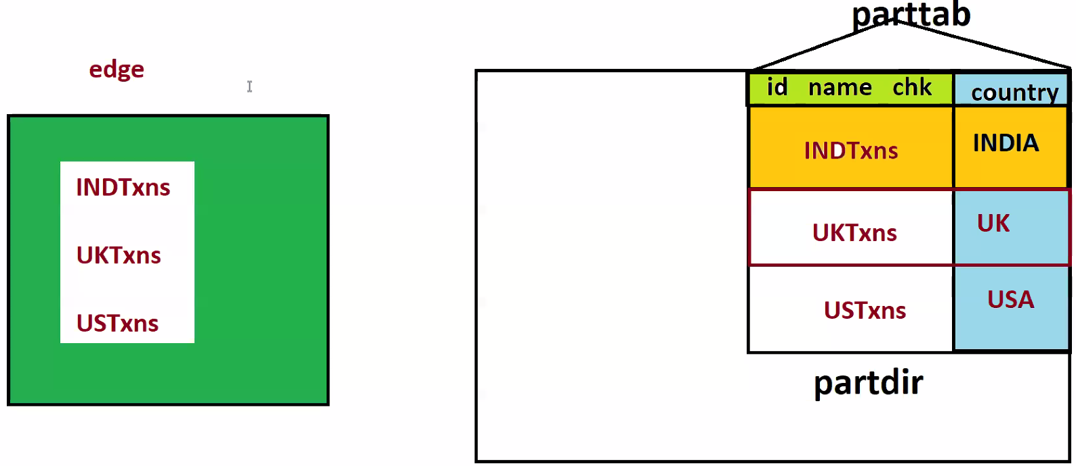

**These types of partitions are called Static Load Partitions (As we are loading data by giving partition value manually)**

**Class: 18 DATE: 21-07-2024**

**STATIC INSERT PARTITION**

Create a directory **sidir**  in hdfs

Create a table with below information

* Table name 🡺 sitab
* Columns 🡺 id int, name string, chk string
* Delimiter 🡺 comma
* Location 🡺 /user/cloudera/sidir
* Partition column 🡺 country string

Once table is create look at below requirement

* In our edge node we have a file known as **allc** which contains all country data(IND,UK,USA). Now, find a way to load only IND records to sidir table with partition name as INDIA.
* We cannot directly load into directly into sidir, take some **temp table insert all data into this temp table then do table to table insert only for IND records.**

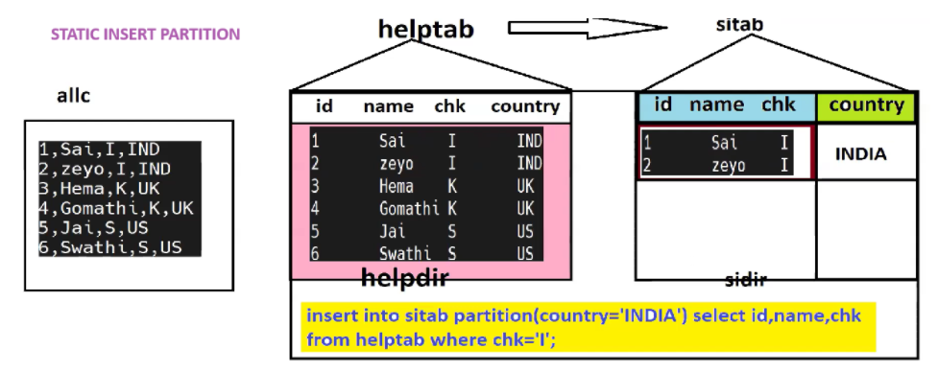

**Commands**:

🔴Static Insert

=====

🔴data creation

========

hadoop dfsadmin -safemode leave

cd

echo 1,Sai,I,IND>allc

echo 2,zeyo,I,IND>>allc

echo 3,Hema,K,UK>>allc

echo 4,Gomathi,K,UK>>allc

echo 5,Jai,S,US>>allc

echo 6,Swathi,S,US>>allc

hadoop fs -rmr /user/cloudera/helpdir

hadoop fs -mkdir /user/cloudera/helpdir

hadoop fs -rmr /user/cloudera/sidir

hadoop fs -mkdir /user/cloudera/sidir

hive -- go inside

======================

🔴Create database and Source Table

======================

create database if not exists partdb;

use partdb;

drop table if exists helptab;

create table helptab(id int,name string,chk string,country string) row format delimited fields terminated by ',' location '/user/cloudera/helpdir';

==================================

🔴Load data to source table

==================================

load data local inpath '/home/cloudera/allc' into table helptab;

==================================

🔴Target table for Statis Partition and insert the data

==================================

drop table if exists sitab;

create table sitab(id int,name string,chk string) partitioned by (country string) row format delimited fields terminated by ',' location '/user/cloudera/sidir';

insert into sitab partition(country='INDIA') select id,name,chk from helptab where country='IND';

quit;

hadoop fs -ls /user/cloudera/sidir

hadoop fs -ls /user/cloudera/sidir/country=INDIA

**DYNAMIC INSERT**

Create a dir /user/cloudera/dyndir

Create a table with below information

* Table name 🡺 dyntab
* Columns 🡺 id int, name string, chk string
* Delimiter 🡺 comma
* Location 🡺 /user/cloudera/dyndir
* Partition column 🡺 country string

Find a way to insert all country data from helptab table with **partition name as country value** from helptab table.

**Commands:**

hdfs dfs -mkdir /user/cloudera/dyndir

create table dyndir(id int, name string, chk string) partitioned by(country string) row format delimited fields terminated by ',';

insert into dyntab partition(country) select id, name, chk, country from tempdir;

Last column directly reference to partition column.

To execute dynamic partition we need to set below property

**set hive.exec.dynamic.partition.mode=nonstrict;**

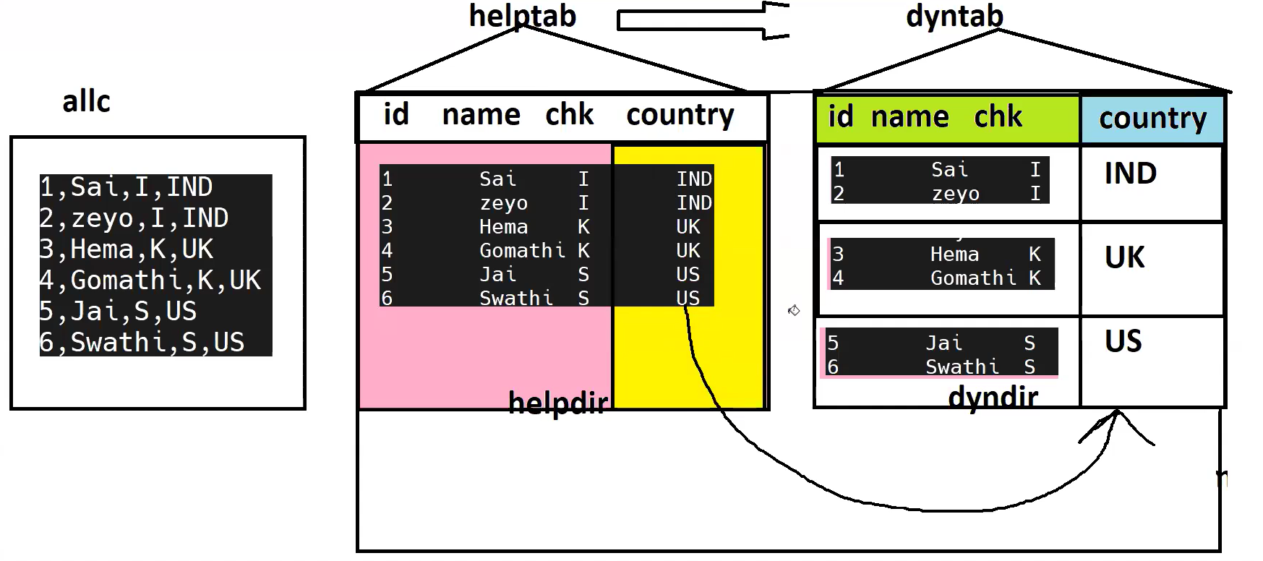

**Class: 19 DATE: 27-07-2024**

**Agenda:**

* **Cloud Hive Analytics**
* **Hive Avro**
* **Project Discussion**

**Cloud Hive Analytics**

Basically, we have three cloud providers, AWS, GoogleCloud, Azure. Hadoop cluster in each of these cloud can be created with EMR(Elastic Map Reduce) in AWS, Dataproc in GCP, HDI nsights in Azure

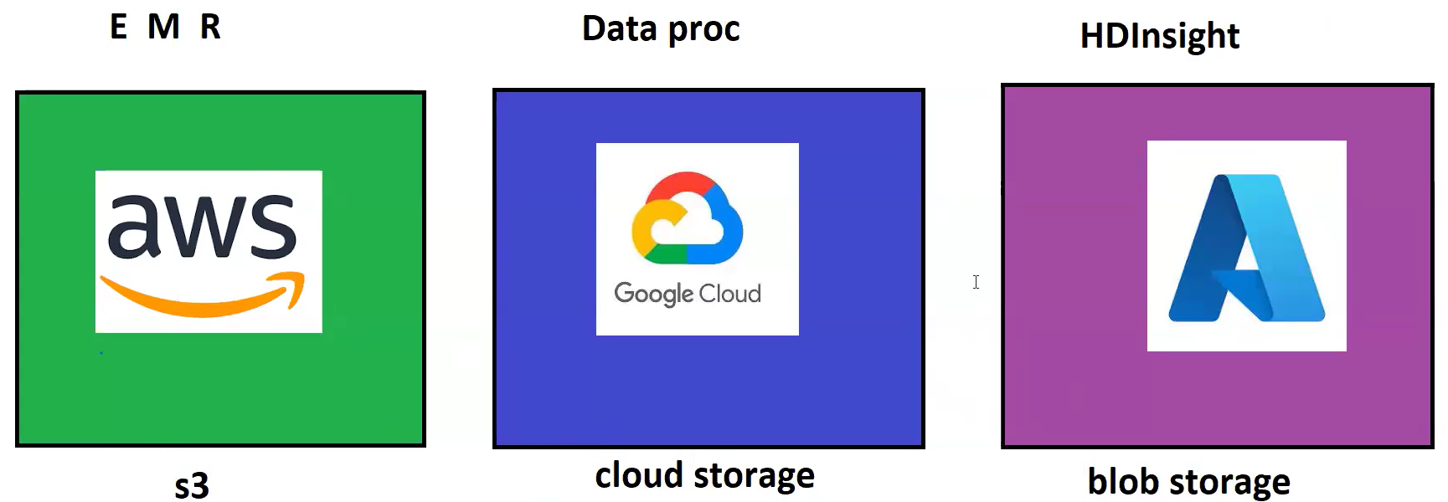

So far we have created tables in the HDFS location in cloudera, but AWS enables S3 also for Hive table creation other than HDFS.

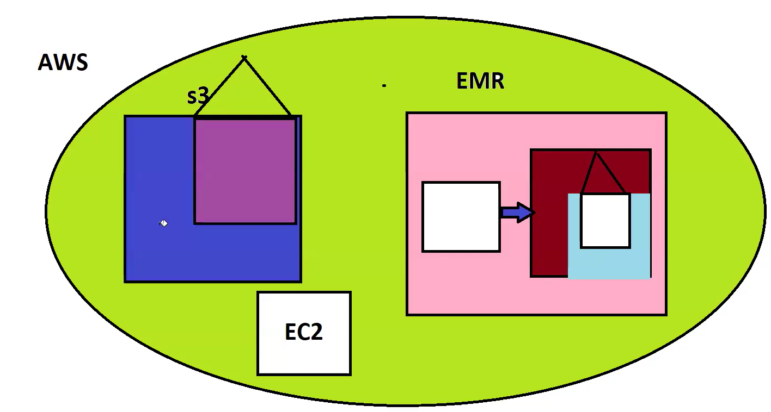

When manged tables created on S3 are dropped the backed data directory will not be deleted. Earlier it used to be deleted/impacted, but recent changes in policies it’s not deleting now.

Hive has access to create table on AWS S3, even though if we create Managed table, it comes as External table. Similarly, with Cloud storage in GCP and Azure Blob storage in Azure cloud also.

**HIVE AVRO Table creation:**

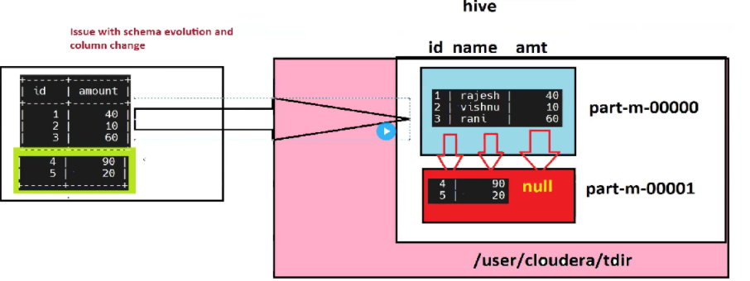

**create table atab(id int, name string, amount int) stored as avro location ‘/user/cloudera/adir’;**

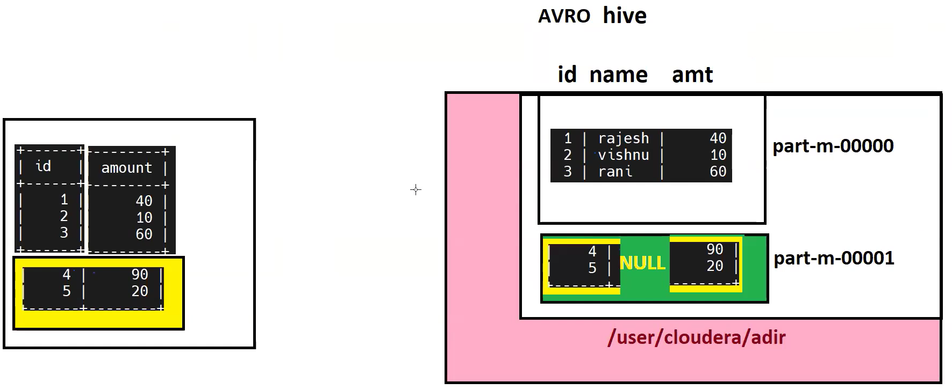

**What made avro to get columns correctly aligned?**

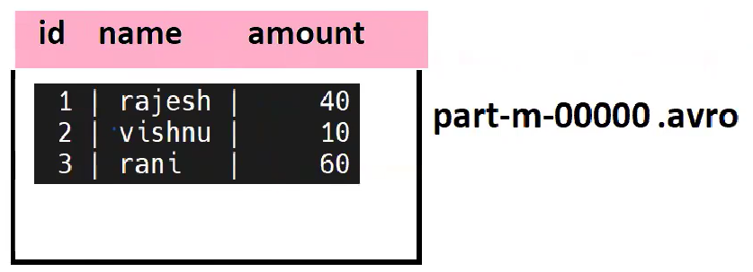When avro file gets created, along with serialized data column will also be part of it. So while mapping new avro data with previous data, it will map it with column to column.

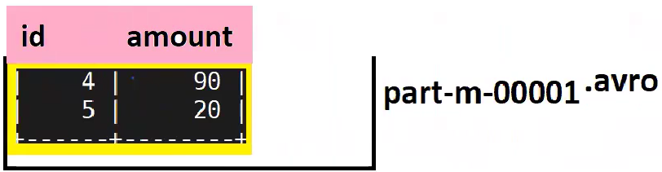

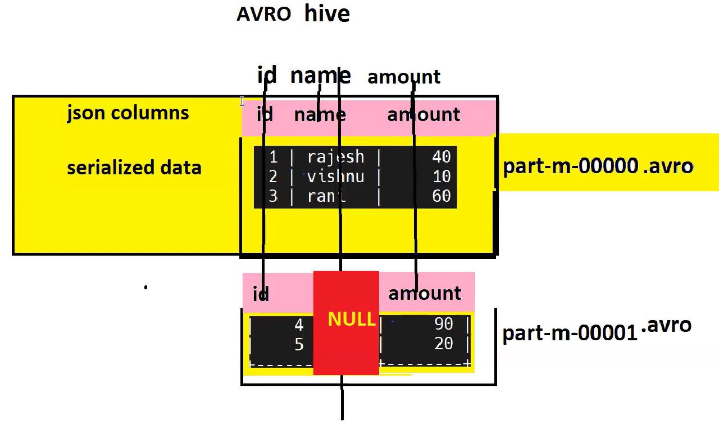

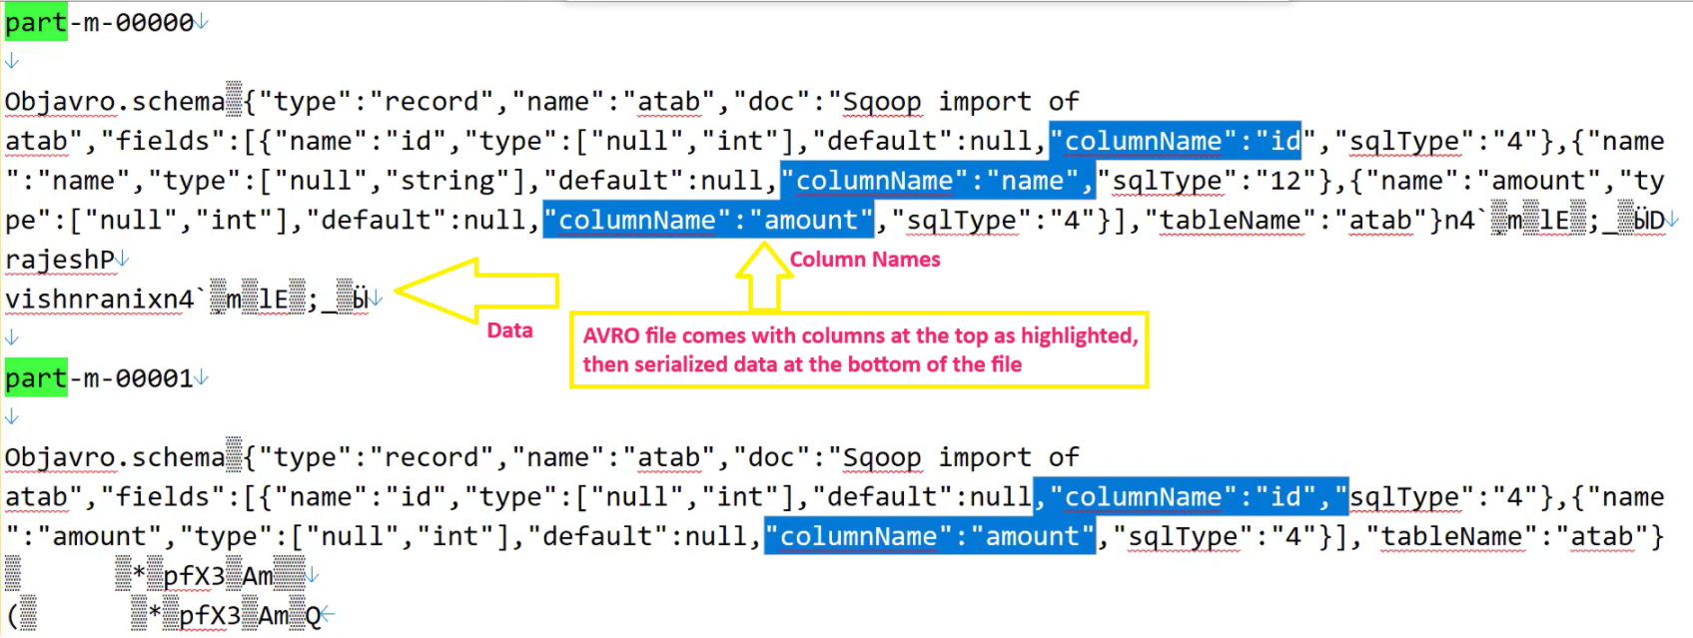

**Handson:**

mysql -uroot -pcloudera

create database if not exists dataa;

use dataa;

drop table if exists atab;

create table atab(id int,name varchar(100),amount int);

insert into atab values(1,'rajesh',40);

insert into atab values(2,'vishnu',10);

insert into atab values(3,'rani',60);

select * from atab;

quit;

================================================

sQOOP Import

sqoop import --connect jdbc:mysql://localhost/dataa --username root --password cloudera --table atab --m 1 --delete-target-dir --target-dir /user/cloudera/adir --as-avrodatafile

================================================

hive -- type and go inside

create database if not exists adb;

use adb;

drop table atab;

create table atab(id int,name string,amount int) stored as avro location '/user/cloudera/adir';

select * from atab;

quit;

=================================================

mysql -uroot -pcloudera

use dataa;

alter table atab drop column name;

insert into atab values(4,90);

insert into atab values(5,20);

select * from atab;

quit;

=================================================

Edge Node

sqoop import --connect jdbc:mysql://localhost/dataa --username root --password cloudera --table atab --m 1 --target-dir /user/cloudera/adir --as-avrodatafile --incremental append --check-column id --last-value 3

=================================================

hive -- type and go inside

select * from adb.atab;

**HIVE PROJECT DETAILS**

We have **customer_total** table in sql, create new table called **customer_src** and insert few records from **customer_total** table.

Create a folder in edge node. Now create a sqoop job and execute that sqoop job. Once sqoop job gets executed, data gets imported inside HDFS. Now create a hive table without hardcoding columns. We will get columns from AVSC file from edge node. Create a folder inside HDFS and create place AVSC file init. And ask hive to create table using AVSC file.

Now, create a target table **customer_target_tab** with 4 partitions (day, month, year, current_date) refer AVSC file for remaining columns.

**Architecture:**

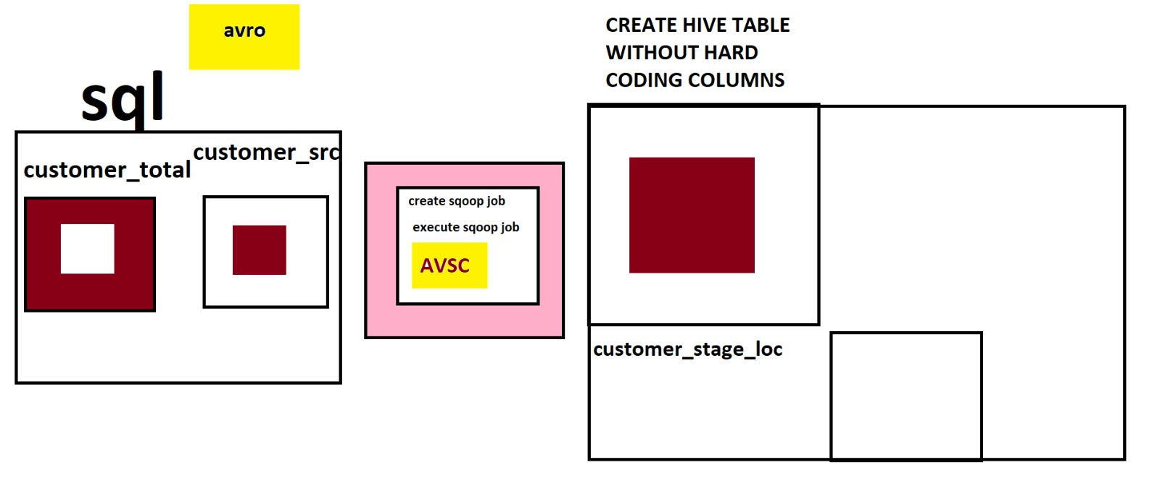

**Handson:**

Go to Mysql

mysql -uroot -pcloudera

Create database if not exists prodb;

use prodb;

select * from customer_total;

create table customer_src(id int(10),username varchar(100),sub_port varchar(100),host varchar(100),date_time varchar(100),hit_count_val_1 varchar(100),hit_count_val_2 varchar(100),hit_count_val_3 varchar(100),timezone varchar(100),method varchar(100),procedure1 varchar(100),value varchar(100),sub_product varchar(100),web_info varchar(100),status_code varchar(100));

insert into customer_src select * From customer_total where id>=301 and id<=330;

quit

=============================

Edge Node

=============================

rm -rf /home/cloudera/avsrcdir

mkdir /home/cloudera/avsrcdir

cd /home/cloudera/avsrcdir

echo -n cloudera>/home/cloudera/passfile

sqoop job --delete inpjob

sqoop job --create inpjob -- import --connect jdbc:mysql://localhost/prodb --username root --password-file file:///home/cloudera/passfile -m 1 --table customer_src --target-dir /user/cloudera/customer_stage_loc --incremental append --check-column id --last-value 0 --as-avrodatafile

sqoop job --list

sqoop job --exec inpjob

hadoop fs -mkdir /user/cloudera/avscdirpro

hadoop fs -put /home/cloudera/avsrcdir/customer_src.avsc /user/cloudera/avscdirpro

====================================

Hive shell

====================================

hive

create database prodb;

use prodb;

create table customer_src ROW FORMAT SERDE 'org.apache.hadoop.hive.serde2.avro.AvroSerDe' STORED AS AVRO LOCATION '/user/cloudera/customer_stage_loc' TBLPROPERTIES ('avro.schema.url'='/user/cloudera/avscdirpro/customer_src.avsc');

select * from customer_src; === U will see the data

create external table customer_target_tab partitioned by (current_day string,year string,month string,day string) ROW FORMAT SERDE 'org.apache.hadoop.hive.serde2.avro.AvroSerDe' STORED AS AVRO LOCATION '/user/cloudera/customer_target_tab' TBLPROPERTIES ('avro.schema.url'='/user/cloudera/avscdirpro/customer_src.avsc');

select * from customer_target_tab; ==== U will not see the data

**Class: 20 DATE: 05-08-2024**

**Agenda:**

* **Hive Performance Tuning**

Hive Performance Tuning

* Partitions
* Parallel Execution
* Engine Change
* Vectorization
* File Formats
* Hive Bucketing
* Map Side Join 🡺 will be discussed during SPARK.

With above listed ways we can increase the performance of hive queries.

Partitions: we have already seen it.

Parallel Execution: In parallel execution, there is some property. That is **set hive.exec.parallel=true;** by default this property is set to **false**. By setting this property to true it automatically increases query performance.

Imagine we have below query,

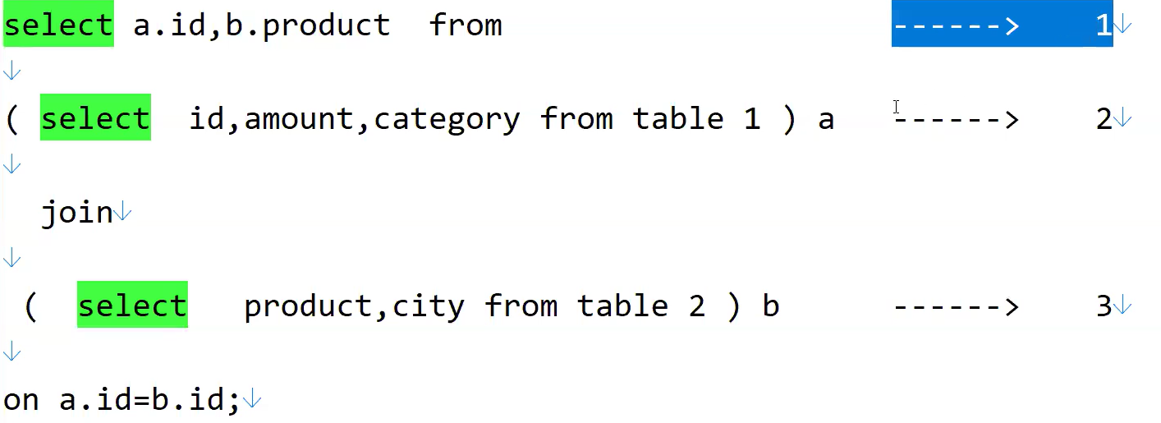

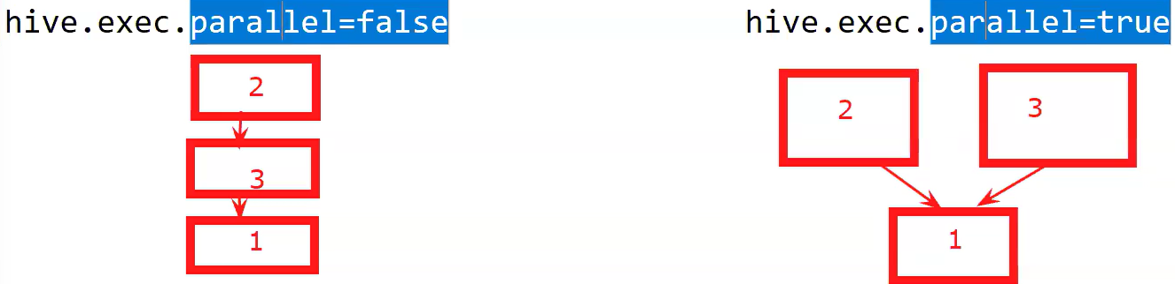

In the above query we have 3 select statements, but select statement1 is dependant on select statement2 and 3, when property set to false, first inner select statements gets executed that is select2 and select3 then outer select1 gets executed sequentially. When we set property to true, both inner select 2and3 gets executed first parallelly then outer select gets executed, this is where we get/attain parallelism.

By default, this property is set to false because parallel execution will increase the performance but its consumes heavy memory. If sometimes ram is not available, query execution gets failed.

Engine Change: For this also there is some property that is **set hive.execution.engine** . By default this property is set to **mr. (set hive.execution.engine=mr) .** But there one more backend engine which runs much faster than mr that is **tez.**

**(Set hive.execution.engine=tez)** all the cloud are configured with tez engine. Tez reduces the processing time by 60%.

Vectorization: For this also there is one property **set hive.vectorized.execution.enaabled=true;** by default its always set to true. By default hive process one row at a time, but if we enabled vectorization it process 1024 rows at a time. We cannot change to some other number.

File Formats: Parquet is best file format for hive to give faster queries. Next comes ORC file format.

Hive Bucketing: (comparatively less used in real time)

Hive bucketing is used when we have high cardinal(many unique values) columns. Example country, id, name, id has high cardinal values.